# CS 255 System Design Document

## UML Diagrams

### UML Use Case Diagram

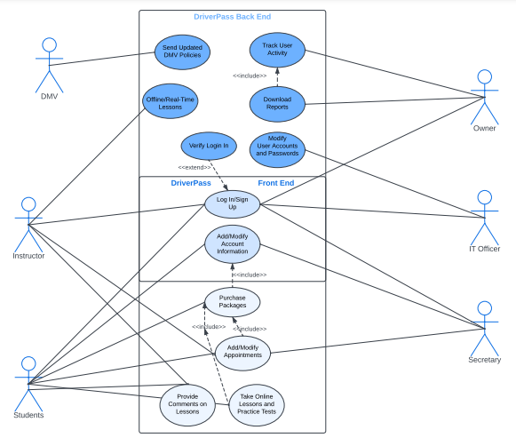

### UML Activity Diagrams

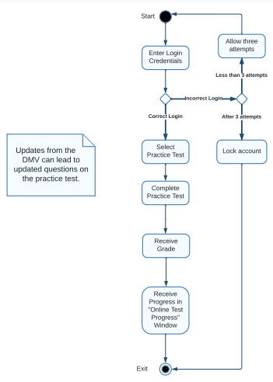

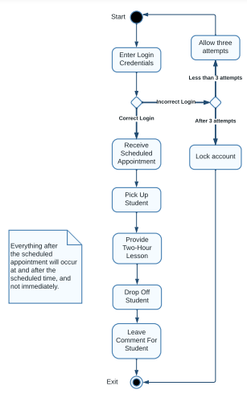

### UML Sequence Diagram

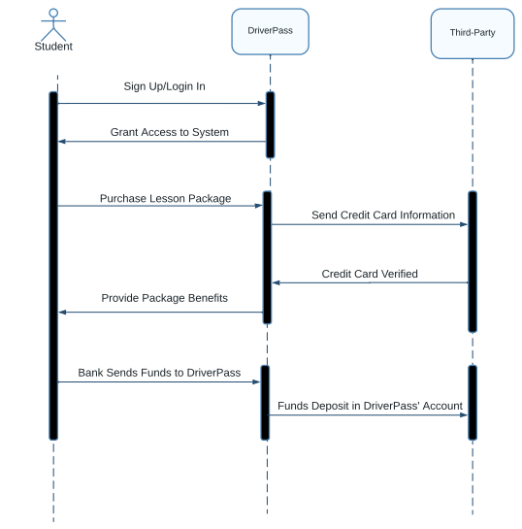

### UML Class Diagram

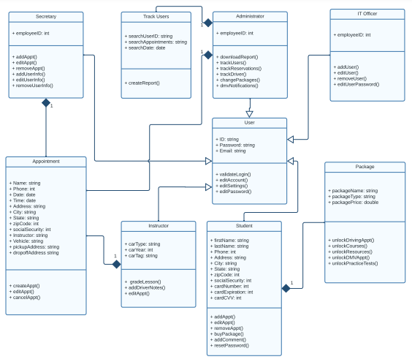

## Technical Requirements

**Hardware for System Design**

When it comes to the hardware needed to access DriverPass, both the client and their customers will need a networking device that connects to the internet. This can be a modem, router, ethernet, etc. Most of these networking devices will require power and cables; therefore, it is important to have these items ready and connected correctly to access the internet. Once the internet is ready to be used, there are multiple ways to access the DriverPass website. The first method is with a desktop computer or a laptop, and the second is a mobile device such as a cellular phone or a tablet. Laptops typically only require a power cord and already have a wireless card installed for wi-fi connection, but a desktop computer will require more hardware parts such as the processing unit itself (sometimes referred to as a tower), at least one monitor, a keyboard, and a mouse. Desktop computers are able to connect to the internet via wi-fi also, but they can also accept an ethernet cord to make a connection. When it comes to laptops there may or may not be a slot for an ethernet cord, but a USB adapter can always be purchased if a user prefers to have an ethernet connection on their laptop. Mobile devices can connect to the internet through wi-fi or through their cellular network.

* Networking device (for internet connection)
* Desktop computer (tower, monitor(s), keyboard, mouse, etc.) or laptop
* Mobile device (to test mobile capabilities)
* Modems
* Routers
* Cables (ex: ethernet)
* Electricity/Power

**Software for System Design**

The most important software when it comes to accessing DriverPass is an operating system (or OS). Popular operating systems include Windows OS, macOS, Linux, Android OS, and iOS. While using an OS—and with the aforementioned means of accessing the internet—both the client and their customers will access DriverPass through an internet browser such as Google Chrome or Mozilla Firefox. When it comes to the administrator and his request to access reports, an office-based software such as MS Office would be recommended since they provide the ability to read and edit reports.

* Operating system software
* Mobile device software
* Web browser
* Office-based software (for documents and spreadsheets, etc.)

**Tools for System Design**

When it comes to tools for building the system itself, there are several free options available for development. The first is Visual Studio. Visual Studio is a powerful tool for development because it offers flexibility. Whether a programmer is focused on C++, Java, Python, or web development, Visual Studio is able to download and install the necessary extensions. Eclipse offers flexibility as well, but it is shines most when programming with Java and C++. Finally, there is PyCharm which focuses more on Python and offers many add-ons for developers who prefer to program with that language. The final tool that would be helpful in developing a system is LucidChart. Programming is not coding alone, and requires a decent amount of planning. Pseudocodes are a reliable method for programmers laying the blueprint for a system like DriverPass, but there are other methods like flowcharts and UML class diagrams to make coding easier. Lucid Chart offers a vast array of different types of charts that programmers can use to take the information they know about a system and turn that information into a map for a program.

* Visual Studio
* Eclipse
* PyCharm
* Lucid Chart

**Infrastructure for System Design**

The DriverPass system will be built on the cloud; therefore, the servers will not be in-house, but with the provider of the cloud service. The provider will also be providing storage for all of the files that will be needed to make the DriverPass system operate as it should. Another piece of infrastructure that DriverPass will need is a firewall. A firewall will provide added layer of protection to the security methods that will be set in place by the cloud provider and by the system programmers as well.

* Cloud server
* Cloud storage
* Firewall